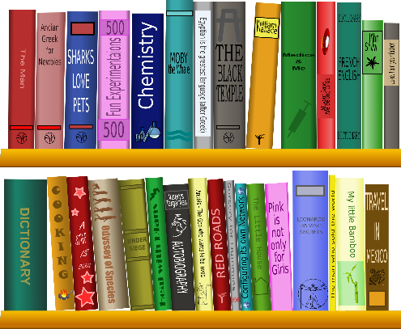
What is the Sora?
Sora is the new user-friendly app that lets you access it through your laptop, phone or tablet. The Sora app was designed around the modern student reading experience. It empowers students to discover and enjoy eBooks and audiobooks from their school, for both leisure and class-assigned reading

Sora is FREE!
Users can access Sora for free at https://soraapp.com or download the app for free through Apple App Store and Google Play, and on Chromebooks™ that support the Google Play Store. Sora is available via desktop, smartphones and
Tablets.

To Access SORA

Google search SORA.
It should be the top option that “Welcome to Sora”. From there, follow this route:
Find my school
My school isn’t listed
Type in “Alberta K-12”
Alberta Public Schools Shared Digital Collection
This is my School
Select Your School
Lethbridge Public School Division # 51
Click GREEN tab
Sign in using child’s school email

*Please keep this sheet as a reference for further use if needed.*

